**Getting a Web Host**

First go to <https://heartland-webhosting.com/>



Click: Start Free Trail

You will see:

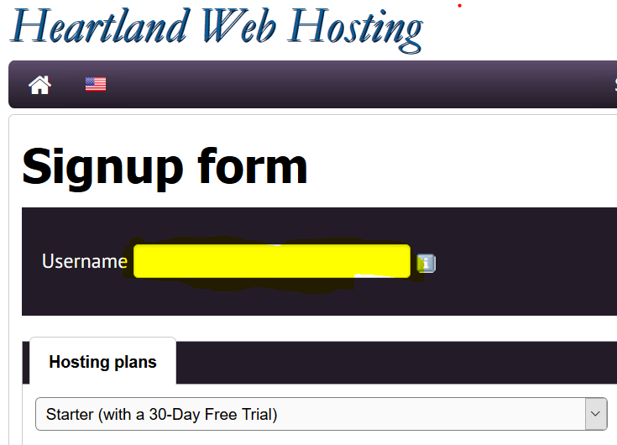

Think about your “Username.”

Choose one you can remember.

Write it down. Type it in.

**HOSTING PLAN**

Leave hosting plans as the default. “Starter (with a 30-Day Free Trial)”

Leave Pre-installed: None

Leave datacenter: Chicago

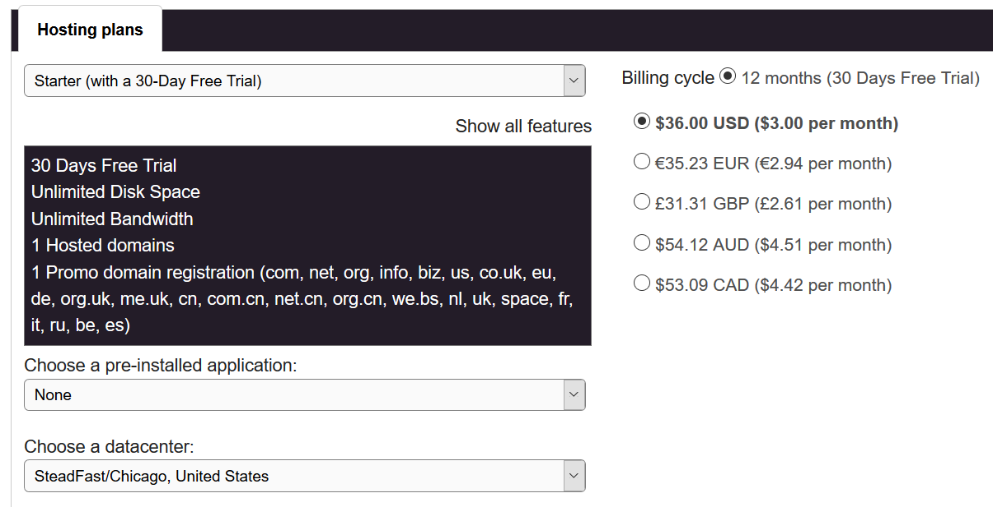

**REGISTER DOMAINS**

Leave it **Blank**. **We will select one later.**

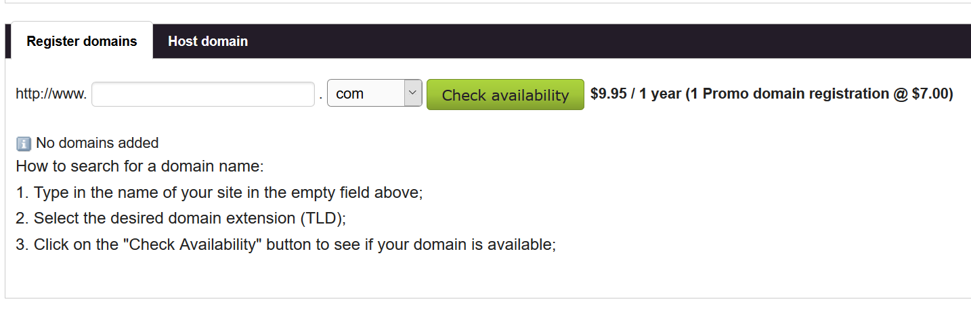

**ACCOUNT OWNER**

Fill in your data. Make sure your email is a working account. Don’t use DMACC unless you do not have any other.

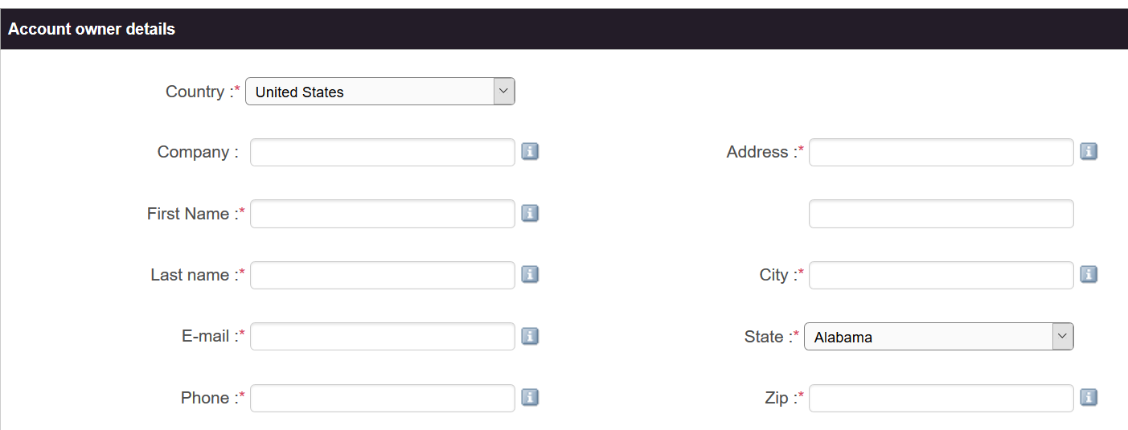

**CREATE ACCOUNT**

Click button once you verify the total is $36.00 USD

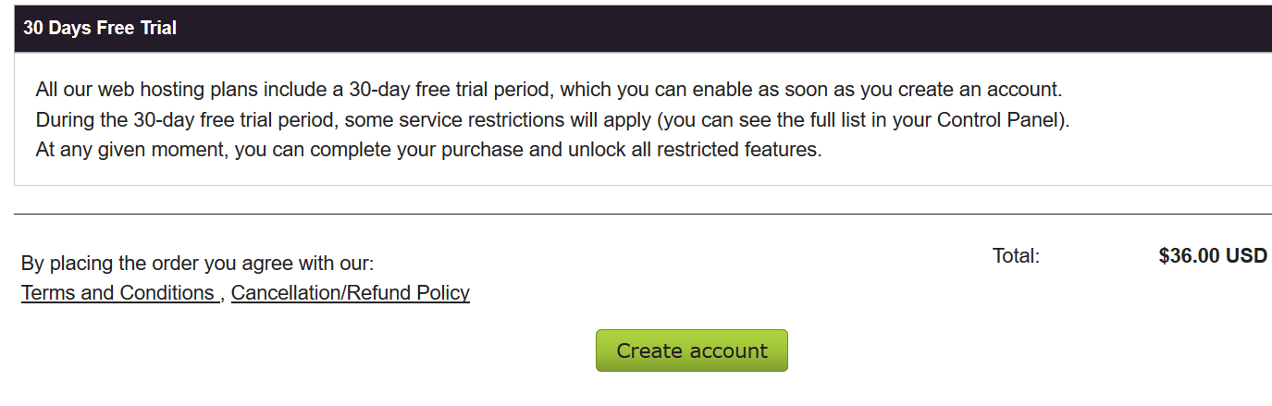

You will receive a couple e-mails.

* One for setting a password

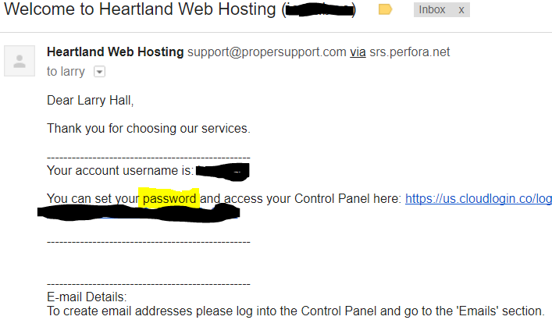

* One for verifying your email address.
* **Make sure you click on the links and do these two things.**

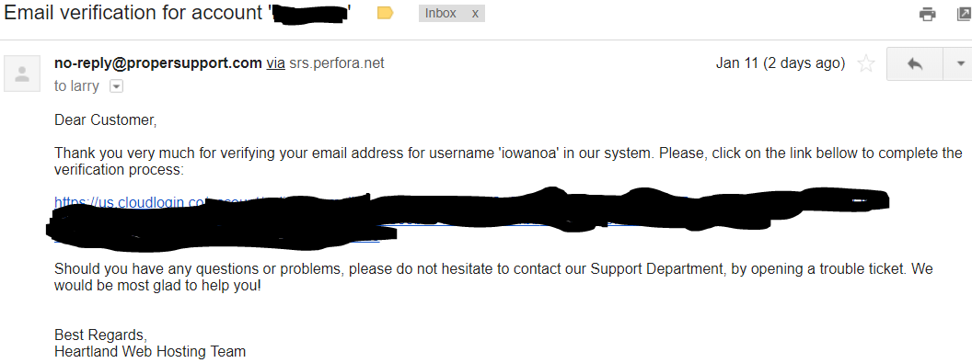

NEXT STEP: GETTING A DOMAIN NAME

See blackboard for the instructions “Registering a Domain Name”